Chapter 15
Devanagari handwritten character recognition using Dynamic routing algorithm

Savita Lonare¹, Rachana Patil², Renu Kachoria³

¹ Pimpri Chinchwad College of Engineering, Pune, India. , savi.lonare@gmail.com*

²Pimpri Chinchwad College of Engineering, Pune, India. Rachana.patil@pccoepune.org
³ Pimpri Chinchwad College of Engineering, Pune, India. , renu.kachoria@pccoepune.org
Abstract. In India, Devanagari is the most commonly spoken and written language. Devanagari is the official language in many institutes or organizations for documentation. Due to digitization, these documents need to restore in digital format. Automatic transcription of images of the handwritten text is a tedious task. This paper addresses the problem of Devanagari's handwritten character recognition. CNN proved its power to classify handwritten text. But CNN fails to recognize the image correctly for rotated images. It is due to the changed spatiality of the rotated image. This paper discusses how the pooling layer of CNN failed in case of disfiguration and Proportional transformation of any image. The paper introduces using Capsule Network for Devanagari text classification. Capsule network uses dynamic routing algoritm which explores the spatial relationship among the features such as size, feature orientation, perspective, etc. The experiments show that the CapsNet improves results over the CNN for the Devanagari handwritten character recognition

Keywords.. Devnagari handwritten character recognition, CapsNet, Dynamic Routing, image classification
  - Introduction
Nowadays, Handwriting character Visibility is one of the active research fields in handwriting recognition. Many handwritten character recognition systems have been researched, experimented with, and adapted for actual use in the past couple of years, seeking high accuracy and trustworthiness. Cursive writing pattern, overlapped letters or numbers, personal style of writing, variation in strokes from person to person increases the complexity of the recognition system. Several supervised methods have been experimented with and published for handwritten digit and character recognition, such as the deep neural network such as convolutional neural networks (CNN) [1]. Even there are works on identifying Marathi's handwritten text where deep learning is used for image classification.[2]–[5]
S. Impedovo et.al.[6] proposed handwritten digit recognition algorithm using multi-objective optimization. They used a non-dominant sorting genetic algorithm for the classification of digits. In another approach, Anuran Chakraborty et al. proposed autoencoder and transfer learning-based image recognition [3]. In [8], Field Programmable Gate Arrays were used for accurate feature extraction; then multilayer perceptron neural network classifier was used for Farsi handwritten digit classification. CNN was the most popular choice for an image classification task among all these approaches.
The majority of the research attained high performance for classification accuracy, more than 98% or 99% [9]. The accuracy on the benchmark dataset MNIST for image classification is achieved by combining various CNNs in an ensemble learning technique [10]. This work further extended to achieve 99.77% recognition accuracy [11] and [12] achieved an accuracy of 98.75%. Niu et al. proposed a hybrid CNN-SVM classifier for recognizing handwritten digits[13]. All these works reported outstanding recognition precision. However, CNN is the primary reason why deep learning is so widespread. CNN worked well for the vast dataset. But CNN has a drawback in its basic construction. Due to this, they are failing in some applications. CNN recognizes features in images and gets trained to recognize the objects with the gained information about the features. The initial hidden layers in CNN detect specific features such as edges, and as CNN gets more profound, the hidden layer can see more complex features. The learning that CNN gains are later used in making a final prediction [14]. The problem with CNN is that CNN cannot learn spatial information about any image. The process of max pooling used in CNN loses most of the vital information as it chooses the most active neuron's weight to be transferred to the next higher layer. At this point, the crucial spatial information gets lost.
Sara Sobour et. al. [14] proposed a dynamic routing based algorithm called capsule to attend this issue. A Capsule network is a type of ANN. A Capsule network is designed to re-use a few capsules' outputs to create stable output for higher-level capsules.
  - Literature review
A noteworthy numeral of research published in handwriting recognition [15]–[19]. SVM has used for handwritten digit recognition for the first time in [20]. Later, many supervised classification problems such as face detection[21] and object recognition[22] were solved using SVM. SVM became the best choice because of its accuracy. In [23], a Freeman Chain Code approach has been used for feature extraction, and a handwritten digit recognition system is proposed using SVM.
In recent years, the availability of more powerful machines, substantial training data, and deep learning methods have become more popular. Particularly for image data CNN achieved enormous success. Many handwritten digit recognition methods were proposed using CNN. These methods achieved high accuracy with MNIST datasets[24]–[27]. The CNN was also proven to identify handwritten Chinese typescripts[28]. LeNet5 CNN architecture-based feature extractor is used on the MNIST database [29]. This approach is demonstrated with excellent recognition accuracy. The impressive performance of the research work proves the efficiency of the CNN feature extraction operation. Further remarkable research on handwriting recognition is given in [30], [31]
Although CNN worked fine, they have some drawbacks. The pooling layer in CNN is responsible for losing valuable information[14]. Recently, the capsule network proposed by Sabour et al. [14] for handwritten digits classification gained researcher's attention due to its capability to overcome the pooling layer in CNN. In this research, the authors worked on MNIST data. This research proposed a novel architecture called capsule Network (CapsNet).
Further, Some capsules may contain noise or redundant data in the dynamic routing [14] process. To ease the disturbance of those capsules, Zhao et al. [32] proposed three approaches. Later, to effectively minimize the computational complexity of dynamic routing, Kim et al. [34] proposed a simple routing method that has accomplished decent results on multiple data sets. A multi-label classification framework was proposed by N. Zhang et al. [35], where the capsule network with attention mechanism has been experimented with. The experiments showed improved results. B. Zhang et al. [34] proposed a CapsNet framework for sentiment analysis in domain adaptation settings with semantic rules, boosting comprehensive sentence representation learning. This model pays distinct consideration to the typical information throughout the training process, efficiently regulates the neural network parameters for various features, and extracts more unseen characteristic details. M. Z. Hasan et al. [35] used Capsule Networks and CNN for changma digit recognition. The results of using CapsNet are superior to that of CNN. The paper is about using CapNet to classify the Devanagari handwritten characters as well as digits over the traditional convolution layer. The experiments shows that CapsNet have better capability of relative spatial features and given better accuracy that the CNN models.
  - Problem with CNN
CNN is essentially a structure where numerous neurons are stacked together. CNN has been extraordinarily outstanding at handling image classification problems. It is very tough to have a neural network map for all the image pixels since it's computationally expensive. So, convolution is a technique that supports you abridge the computation cost to a great level without losing the crucial features of the data. Fig. 1 shows a typical structure of a CNN model. CNN model performs convolution that involves a lot of matrix multiplication and summation of those results. It also has a pooling layer to extract the essential information to pass it to the next layer. The problem with CNN is that the CNNs perform remarkably well when classifying images that are very similar to the data set.
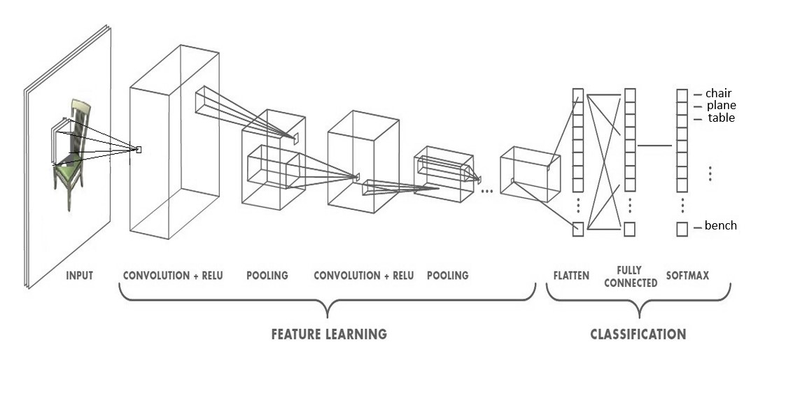
Figure 1. CNN structure
If the pictures have tilt, rotation, or any other diverse positioning, CNNs have poor performance. This issue gets solved by introducing different variations of a similar image while training. Each layer comprehends an image at a much more fundamental level in CNN. Suppose you are trying to classify trucks and cars. The very basic curves and boundaries are recognized by first layer. The second layer might recognize the straight lines or the smaller shapes, like front look of the car and truck. Higher layers understand more complex shapes like the whole car or truck.
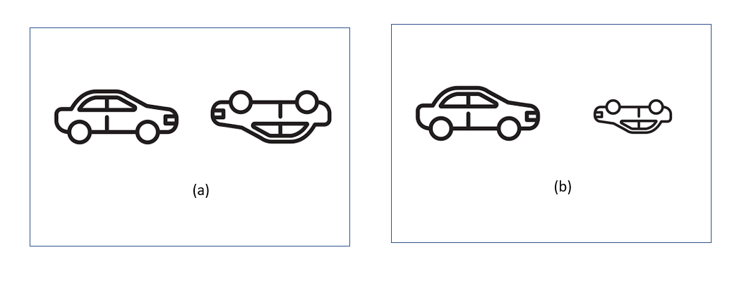
Figure 2 : a) Disfiguration transformation b) Proportional transformation
CNN uses pooling after each layer for computations in realistic time frames. But in reality, it also loses out the positional data. The pooling layer helps in creating positional invariance. Without a pooling layer, CNNs would fit only the data very close to the training set. This invariance also triggers false positives for images that have the components of a car but are not in the exact sequence. So the structure can trigger the right to match the left in the images shown in Fig.2 a). An observer can see the difference. The pooling layer also adds this kind of invariance. It wasn't the purpose of the pooling layer. The pooling was supposed to add a proportional, positional and orientational invariance instead of adding all types of positional invariance. This leads to the problem of detecting the car in right image from Fig. 2 a) as a correct car. In this case, we needed equivariance instead of invariance. Due to Invariance CNN becomes tolerant to minor changes in the viewpoint. Because of this issue CNN could not realize that the image on the right is a similar but rotated car image.
On the other hand, Equivariance makes a CNN realize the alternation or slight change and adjust itself accordingly to avoid losing spatial positioning inside an image. A car will still be smaller, but the CNN will decrease its size to identify the image. This problem leads to the recent progression of CapsNet.
  - Capsule Network

In terms of neuron networks, network structure, dissemination, and interlayer distribution methods, there are noteworthy differences between CapsNet and CNN architectures [36]. The capsule is an essential structure in CapsNet. Unlike the typical system of neuron networks, the parameters used as inputs and outputs in CapsNet are the vectors. Therefore, the internal parameters correspond to the vectors, which differ from the used activation functions. To be more precise, neuron inputs and output vectors used in a capsule indicate the parameters used for configuring a particular kind of entity, i.e., the vector length suggests the probability of the presence of an entity, and the vector direction represents the occurrence of the entity attribute.

Generally, CapsNet is designed to get inverse graphics. Every capsule in CapsNet receives an input image, and it identifies the object in that image with initial parameters[14]. Thus, the capsules are defined as functions that can predict the initial parameters of the chosen object in a particular area. The length of the activation vector represents the predicted probability of an object. Similarly, the orientation of the activation vector shows the parameter instantiation of the object. CapsNet is strong enough to integrate flexibility. CapsNet can translate image measurement parameters like rotation, slope, extension, thickness, etc. Since the length of the vector represents a probability that must be less than or equal to 1, which is calculated using a squashing function. At every layer, the capsule's purpose is to predict the effect of the successive layers based on the prior layer. To make prediction, a dot product is used. The hierarchy is easily accessible by observing the opening and understanding the components associated with high accuracy.

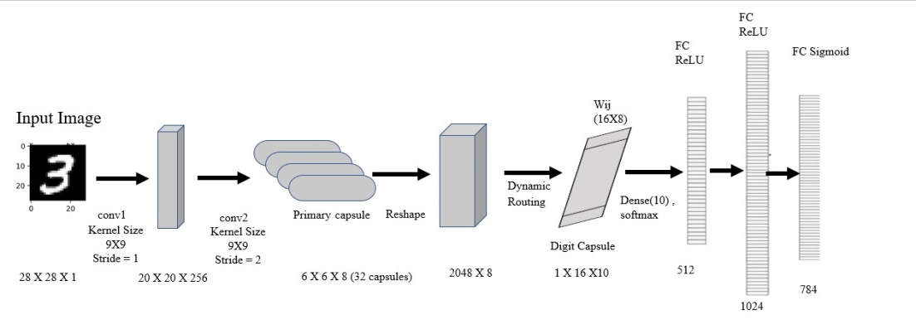
Figure 3: CapsNet Model
The structure of CapsNet for handwritten Devnagari character recognition is straightforward. The model for a CapsNet is shown in Fig.3. which consists of different layers. CapsNet initially has two convolution layers followed by a primary capsule. After the primary capsule (PriCaps), there is a second layer comprised of DigitCaps. The last layer of CapsNet is fully connected layers. The CapsNet model shown in Fig.3 is used for identifying handwritten character images. For this research, Devanagari character images with dimensions 28x28x1 are given as input to the CapsNet. The initial convolution layers have the same kernels, but it differs in stride. ReLU activation function is used to activate convolution layers which produce different feature maps as layer outputs. These feature maps are then reshaped to form the primary capsule layer. The PriCaps layer constructs the corresponding vectors and works as the capsule input layer. This layer also reshapes the input, then fed to an input vector for the subsequent layers. The DigitCaps layer shown in Fig.3 is the output layer for the capsule. The loss function for the classification, which encodes the image into the character, is present after the DigitCaps layer. The fully connected (FC) layers act as a decoder responsible for reconstructing the image. The FC layers also prevent overfitting. DR algorithm[14] works between the PriCaps and the DigitCaps. The DR algorithm updates the necessary parameters along with the traditional back-propagation algorithm.
  - Introduction of Devanagari character set
Devanagari is one of the viral scripts in India because it is the foundation for languages such as Marathi, Hindi, Nepali, and Sanskrit [37]. Unlike other foreign languages such as English, Japanese, Russian text, there is a horizontal line on the word called "Shirorekha". This horizontal line also denotes the end of the word. There are 58 characters in the Devanagari script. The writing way of the Devanagari is a combination of characters, numerals, and some modifiers. It follows the phonetic principle where many characters follow a combination of vowels and consonants. Devanagari script is also known as phonetic script because writing also considers the sounds of the characters. Along with consonants, it has 14 modifiers that are used with consonants. For example, a modifier 'ा' used with consonant 'ग' is written like 'ग?आ=गा’ .
  - Challenges in recognizing Devanagari character
The notable feature which makes Devanagari more multifaceted is the resemblance of characters. For example , रा and श; प and ष, घ and ध etc. Different individuals' writing style and stoke make it challenging to differentiate characters, mainly when they are handwritten. This research aims to take advantage of CapsNet for detecting the spatiality of every character feature.
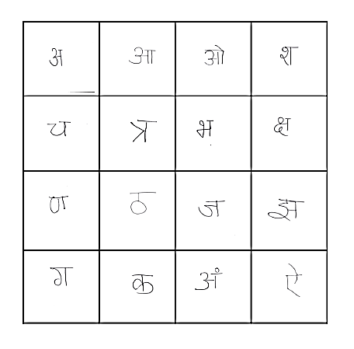
Figure 4: Devanagari character dataset samples

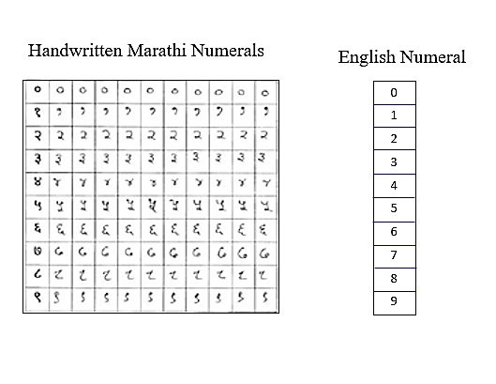
Figure 5: Handwritten Devanagari Digits and Equivalent English Digits
  - Experiment
The data used in this research is available on Kaggle[38]. The dataset contains 5800 samples with 58 character classes and ten numerals for the Devanagari script. Each character and digit have 100 sample images. The samples are pre-processed to create image of size 28x28x1. Fig. 4 and Fig5. shows the sample numeral and character images present in the dataset.
A feature map at each layer of the CapsNet (encoder) is shown in Fig3. The model accepts handwritten character image a with a size of 28x28x1 and encode it into a 16 dimension vector of instantiation parameters called Digit Capsule in various classes. The Convolution layers are classic convolution layers with the activation function ReLU to extract local features from the image. There are two convolutional layers. First Conv1 with 9x9 convolutional kernel, a stride of 1 and, has ReLU activation function. And another Conv2 with a 9x9 convolutional kernel, a stride of 2, and a ReLU activation function. Conv1 results in 20x20x256 features, and Conv2 results in 6x6x8x32 features of scalars. The output is then reshaped to obtain 2048x8 features of vectors.
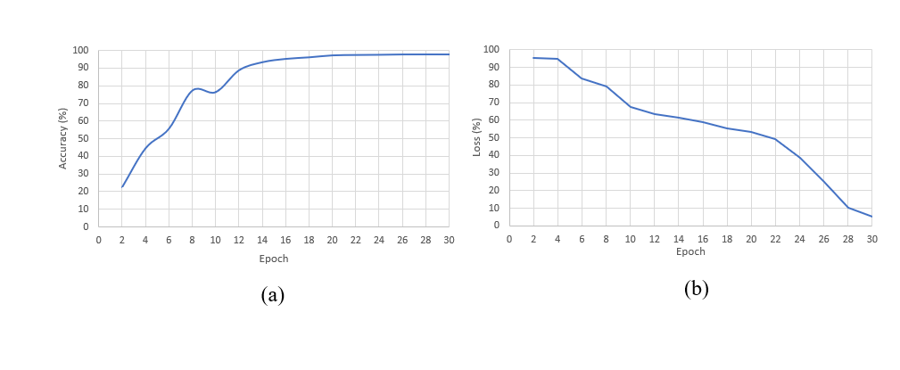
Figure 5 . a )Testing Accuracy b) Testing Loss

Model | Accuracy
Reddy et al. [39] | 97.33%
Deore et al. [38] | 97.45%
Saha et al.[40] | 93.00%
CapsNet Model | 97.88%

Table 1: Testing Accuracy
  - Results and Discussion
The proposed model experimented with the Devanagari characters dataset, containing 5800 Devanagari characters. The training set contains random 80% images for every character; the remaining 20% a used for the testing set. The total number of classes for the character is 48, and for numbers 10. The model was executed for 30 epochs with a batch size of 20. Table 1 shows the performance of the CapsNet model over other models for handwritten character prediction. The CapsNet model shows slight improvement over the CNN model. Fig. 5 a) and b) shows the accuracy and loss graph over the iterations. The testing accuracy is improving with the decrease in the loss for 30 iterations. For image processing, this work used Keras ImageDataGenerator class. The CapsNet model achieved 94.56% training and 97.88% testing accuracy. The experiment is also conducted for the resemblance of characters. The CapsNet successfully recognized the spatial relationship of features and could differentiate the characters with similar characteristics.

  - Conclusion and Future scope
Individual’s writing style makes Character detection in Indian languages is difficult and complex. Many characters in Devanagari differs slightly from other. In the case of CNN, these features get lost while training the model due to the pooling layer. CapNet can learn these slight differences and understand every spatial phenomenon. This work uses the CapsNet model to classify the isolated handwritten Devanagari characters. This work used a Kaggel dataset for Devanagari font. CapNet have given the accuracy of 97.88%. In the future, exploiting CapNet for more complex languages is planned.

References
[1] S. Ahlawat and A. Choudhary(2020) Hybrid CNN-SVM Classifier for Handwritten Digit Recognition. Procedia Computer Science, 167, pp. 2554–2560. https://10.1016/j.procs.2020.03.309.
[2] V. T. Lanjewar and R. N. Khobragade(2021) Transfer learning using Pre-trained AlexNet for Marathi Handwritten Compound Character Image Classification. International Conference on Intelligent Technologies, CONIT 2021. https://10.1109/CONIT51480.2021.9498418.
[3] Y. Gurav, P. Bhagat, R. Jadhav, and S. Sinha(2020) Devanagari Handwritten Character Recognition using Convolutional Neural Networks. 2nd International Conference on Electrical, Communication and Computer Engineering, ICECCE 2020. https://10.1109/ICECCE49384.2020.9179193.
[4] Prashant Misal, Prof.A.J.Patankar and Dr. Nitika Singhi (2021),Handwritten Marathi Character recognition using Deep learning - Inpressco.
[5] P. M. Kamble and R. S. Hegadi(2015) Handwritten Marathi Character Recognition Using R-HOG Feature,” Procedia Computer Science, vol. 45, no. C, pp. 266–274. https://10.1016/J.PROCS.2015.03.137.
[6] S. Impedovo, G. Pirlo, and F. M. Mangini(2012) Handwritten digit recognition by multi-objective optimization of zoning methods,” Proceedings - International Workshop on Frontiers in Handwriting Recognition, IWFHR, pp. 675–679. https://10.1109/ICFHR.2012.209.
[7] A. Chakraborty, R. De, S. Malakar, F. Schwenker, and R. Sarkar( 2020), “Handwritten digit string recognition using deep autoencoder based segmentation and ResNet based recognition approach,” Proceedings - International Conference on Pattern Recognition, pp. 7737–7742, 2020. https://10.1109/ICPR48806.2021.9412198.
[8] M. Moradi, M. A. Poormina, and F. Razzazi, “FPGA implementation of feature extraction and MLP neural network classifier for Farsi handwritten digit recognition,” EMS 2009 - UKSim 3rd European Modelling Symposium on Computer Modelling and Simulation, pp. 231–234, 2009. https://10.1109/EMS.2009.13.
[9] K. Jarrett, K. Kavukcuoglu, M. Ranzato, and Y. LeCun, “What is the best multi-stage architecture for object recognition?,” Proceedings of the IEEE International Conference on Computer Vision, pp. 2146–2153, 2009. https://10.1109/ICCV.2009.5459469.
[10] D. C. C. Cires¸an, U. Meier, J. Masci, L. M. Gambardella, and J. ¨ Urgen Schmidhuber, “Flexible, High Performance Convolutional Neural Networks for Image Classification”.
[11] D. Ciregan, U. Meier, and J. Schmidhuber, “Multi-column Deep Neural Networks for Image Classification,” Proceedings of the IEEE Computer Society Conference on Computer Vision and Pattern Recognition, pp. 3642–3649, Feb. 2012. https://10.1109/CVPR.2012.6248110.
[12] G. E. Hinton, S. Osindero, and Y.-W. Teh, “A fast learning algorithm for deep belief nets *”.
[13] X. X. Niu and C. Y. Suen, “A novel hybrid CNN–SVM classifier for recognizing handwritten digits,” Pattern Recognition, vol. 45, no. 4, pp. 1318–1325, Apr. 2012. https://10.1016/J.PATCOG.2011.09.021.
[14] S. Sabour, N. Frosst, and G. E. Hinton, “Dynamic Routing Between Capsules,” Oct. 2017, [Online]. Available: http://arxiv.org/abs/1710.09829
[15] K. M. Sayre, “Machine recognition of handwritten words: A project report,” Pattern Recognition, vol. 5, no. 3, pp. 213–228, Sep. 1973, https://10.1016/0031-3203(73)90044-7.
[16] A. Graves, “Offline Handwriting Recognition with Multidimensional Recurrent Neural Networks.”
[17] Online and off-line handwriting recognition: a comprehensive survey | IEEE Journals & Magazine | IEEE Xplore. https://ieeexplore.ieee.org/document/824821 (accessed Feb. 17, 2022).
[18] C. N. Manisha, E. S. Reddy, and Y. K. Sundara Krishna, “Role of Offline Handwritten Character Recognition System in Various Applications,” International Journal of Computer Applications, vol. 135, no. 2, pp. 975–8887, 2016.
[19] J. A. Sánchez, V. Bosch, V. Romero, K. Depuydt, and J. de Does, “Handwritten text recognition for historical documents in the transcriptorium project,” ACM International Conference Proceeding Series, pp. 111–117, 2014. https://10.1145/2595188.2595193.
[20] C. Cortes, V. Vapnik, and L. Saitta, “Support-vector networks,” Machine Learning 1995 20:3, vol. 20, no. 3, pp. 273–297, Sep. 1995. https://10.1007/BF00994018.
[21] P. J. Phillips, “Support Vector Machines Applied to Face Recognition”.
[22] M. Pontil and A. Verri, “Support vector machines for 3D object recognition,” IEEE Transactions on Pattern Analysis and Machine Intelligence, vol. 20, no. 6, pp. 637–646, 1998. https://10.1109/34.683777.
[23] A. Boukharouba and A. Bennia, “Novel feature extraction technique for the recognition of handwritten digits,” Applied Computing and Informatics, vol. 13, no. 1, pp. 19–26, Jan. 2017, https://10.1016/J.ACI.2015.05.001.
[24] K. Jarrett, K. Kavukcuoglu, M. Ranzato, and Y. LeCun, “What is the best multi-stage architecture for object recognition?,” Proceedings of the IEEE International Conference on Computer Vision, pp. 2146–2153, 2009, https://10.1109/ICCV.2009.5459469.
[25] D. C. Cireşan, U. Meier, J. Masci, L. M. Gambardella, and J. Schmidhuber, “Flexible, high performance convolutional neural networks for image classification,” IJCAI International Joint Conference on Artificial Intelligence, pp. 1237–1242, 2011. https://10.5591/978-1-57735-516-8/IJCAI11-210.
[26] D. Ciregan, U. Meier, and J. Schmidhuber, “Multi-column deep neural networks for image classification,” Proceedings of the IEEE Computer Society Conference on Computer Vision and Pattern Recognition, pp. 3642–3649, 2012. https://10.1109/CVPR.2012.6248110.
[27] G. E. Hinton, S. Osindero, and Y. W. Teh, “A fast learning algorithm for deep belief nets,” Neural Comput, vol. 18, no. 7, pp. 1527–1554, 2006. https://10.1162/NECO.2006.18.7.1527.
[28] X. Qu, W. Wang, K. Lu, and J. Zhou, “Data augmentation and directional feature maps extraction for in-air handwritten Chinese character recognition based on convolutional neural network,” Pattern Recognition Letters, vol. 111, pp. 9–15, Aug. 2018. https://10.1016/J.PATREC.2018.04.001.
[29] F. Lauer, C. Y. Suen, and G. Bloch, “A trainable feature extractor for handwritten digit recognition A trainable feature extractor for handwritten digit recognition A trainable feature extractor for handwritten digit recognition,” Pattern Recognition, no. 6, pp. 1816–1824, 2007. https://10.1016/j.patcog.2006.10.011ï.
[30] M. D. Zeiler and R. Fergus, “LNCS 8689 - Visualizing and Understanding Convolutional Networks,” 2014.
[31] A. Krizhevsky, I. Sutskever, and G. E. Hinton, “ImageNet classification with deep convolutional neural networks,” Commun ACM, vol. 60, no. 6, pp. 84–90, May 2017. https://10.1145/3065386.
[32] W. Zhao, J. Ye, M. Yang, Z. Lei, S. Zhang, and Z. Zhao, “Investigating Capsule Networks with Dynamic Routing for Text Classification,” Proceedings of the 2018 Conference on Empirical Methods in Natural Language Processing, EMNLP 2018, pp. 3110–3119, Mar. 2018. https://10.18653/v1/d18-1350.
[33] N. Zhang, S. Deng, Z. Sun, X. Chen, W. Zhang, and H. Chen, “Attention-Based Capsule Networks with Dynamic Routing for Relation Extraction,” Proceedings of the 2018 Conference on Empirical Methods in Natural Language Processing, EMNLP 2018, pp. 986–992, Dec. 2018. https://10.18653/v1/d18-1120.
[34] B. Zhang, X. Xu, M. Yang, X. Chen, and Y. Ye, “Cross-domain sentiment classification by capsule network with semantic rules,” IEEE Access, vol. 6, pp. 58284–58294, 2018. https://10.1109/ACCESS.2018.2874623.
[35] M. Z. Hasan, K. M. Z. Hasan, S. Hossain, A. al Mamun, and M. Assaduzzaman (2019) Handwritten Changma numerals recognition using capsule networks,2019 5th International Conference on Advances in Electrical Engineering, ICAEE 2019, pp. 386–391. https://10.1109/ICAEE48663.2019.8975468.
[36] M. Khodadadzadeh, X. Ding, P. Chaurasia, D. Coyle, and S. Member,(2021) A Hybrid Capsule Network for Hyperspectral Image Classification; A Hybrid Capsule Network for Hyperspectral Image Classification,” IEEE Journal of Selected Topics in Applied Earth Observations and Remote Sensing, vol. 14. https://10.1109/JSTARS.2021.3126427.
[37] U. Pal and B. B. Chaudhuri (2004) Indian script character recognition: A survey, Pattern Recognition, vol. 37, no. 9, pp. 1887–1899, https://10.1016/J.PATCOG.2004.02.003.
[38] S. P. Deore and A. Pravin (2020) Devanagari Handwritten Character Recognition using fine-tuned Deep Convolutional Neural Network on trivial dataset,Sadhana - Academy Proceedings in Engineering Sciences, vol. 45, no. 1. https://10.1007/S12046-020-01484-1.
[39] R. V. K. Reddy and U. R. Babu(2019) Handwritten Hindi Character Recognition using Deep Learning Techniques, International Journal of Computer Sciences and Engineering, vol. 7, no. 2, pp. 1–7. https://10.26438/IJCSE/V7I2.17.
[40] P. Saha and A. Jaiswal(2020) Handwriting Recognition Using Active Contour,” Advances in Intelligent Systems and Computing, vol. 1056, pp. 505–514.https://10.1007/978-981-15-0199-9_43.

